VRRRRRRGHH Pirates

Obinna Onyima

Shamario Scott

Kristian Chery

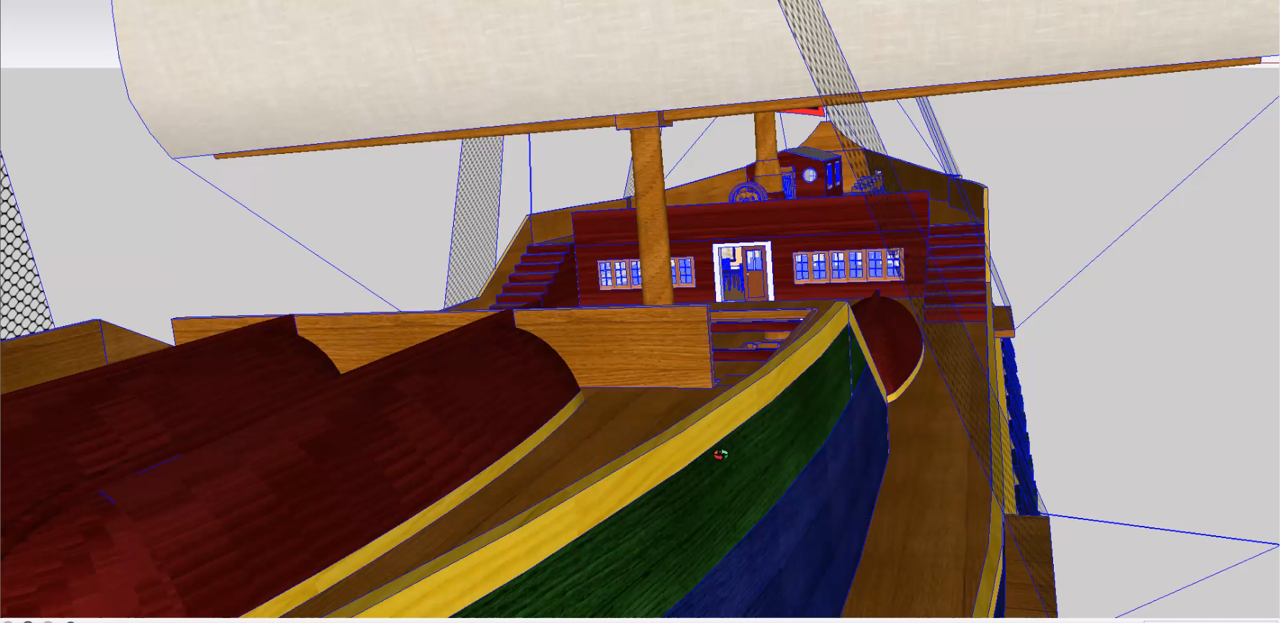

**Preface**

VRRRRGGGGHH Pirates is a project that would incorporate the virtual world with the swashbuckling adventures of the pirate world.

**Goals of the Project**

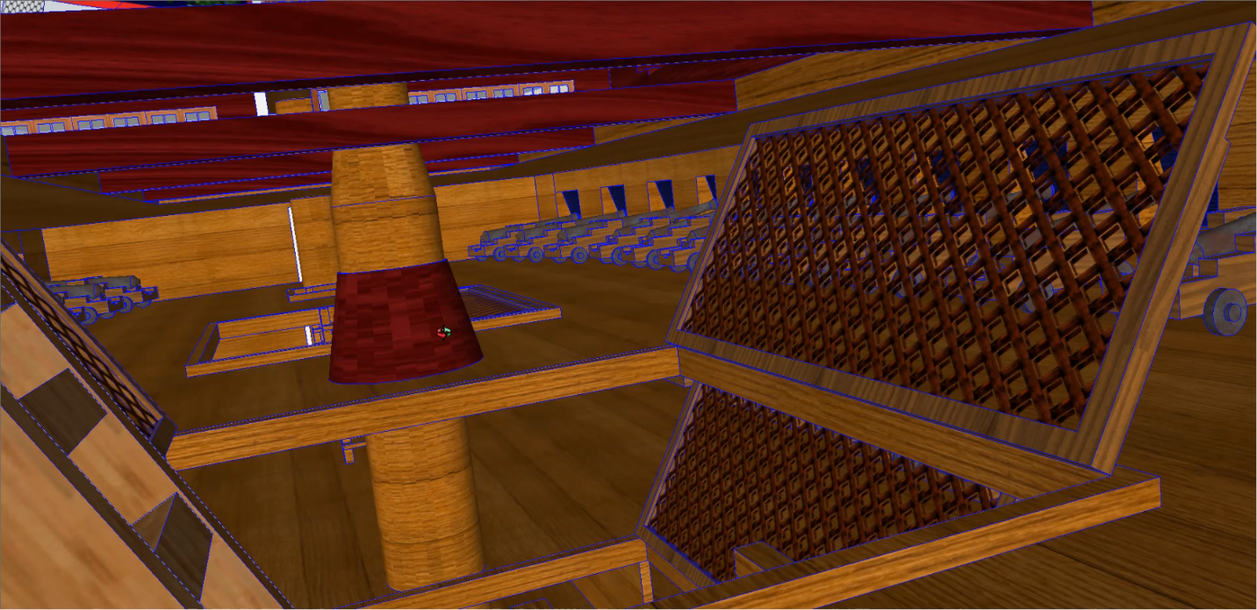

The project was to have the user start on board of a large ship vessel designed from the early ships from the early 1500’s inspired from Spanish and British ships. This project's most important aspect is the ship. Built for the tough seas and its tough sailors, this marvel of the sea ready to sail. The ship itself would be the first adventure for the user where the sheer size of the ship would allow for the first exploration of this project. The user would start at the upper deck of the ship where they are allowed to survey their surroundings and walk around the ship. They are encouraged to walk along the upper deck and see everything the upper deck has to look like. The upper deck houses the captains war room as well as the secondary armory. The helm of the ship is directly above the war room and that will come in later in this simulation. Then the user has to walk down to the second level of the ship where they will be prompted to begin to meet the crew, rooms and special objects. The second deck of the ship holds most of the cannons. Also on the front side of the ship are the showers and lavatory quarters for the sailors of the ship. The captains main room is at the front of the ship on the second floor. That would be the first proximity sensor that would be triggered for the completion of the exploration of the ship. On the back side of the ship on the second floor are the sailor’s quarters. There is where the next three proximity sensors will be in the because the user will be meeting three of his sailors on the ship. The third level of the ship houses more the ships cannons. It also holds the dining room for the crew of the ship. The fourth level of the ship hold even more cannons and is the ammunition storage of the ship. Her the user will meet another member of the crew that will prompt them a blurb of information about the cannons on the ship. The fifth level of the ship is the food storage space. Live cattle like cows and chicken live on this level as well as the edible carcasses that are needed to feed the crew over their voyage. The fifth floor also holds the treasure of the ship and another proximity sensor to be triggered. Meeting the sailor that guards the loot prompts you to then go down to the next floor down. The sixth level of the ship brings the user to the bridge of the ship. All of the prisoners caught by this band of sailors lay captive in this ships prison. Captives like SpongeBob Squarepants and Spiderman will mark that you have finished the exploration part of the ship. The user will be directed back but to the helm of the ship where the second part of the adventure would start. The ship will dock at our island where they will have the second adventure of finding the treasure on said island. When the user finds the treasure on this island, the simulation will end and the user will be brought back to the beginning of the simulation to try again.

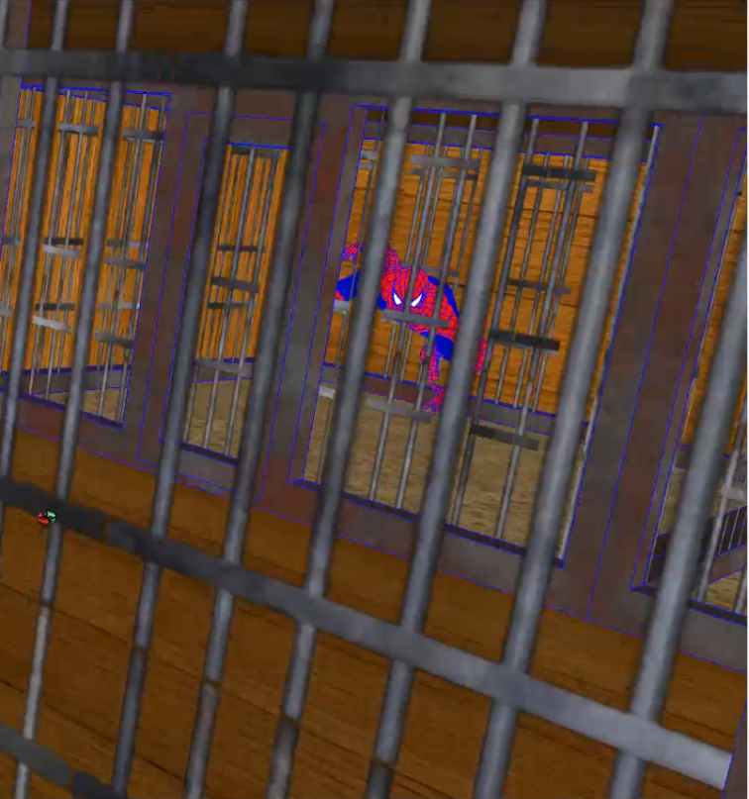

The intention of this project is to make a fantasy exploration Pirate adventure. Purely for entertainment, this adventure is aimed for the user to have fun walking round the ship as well as the island. Our target audience would be pirate fans, exploration game fans and especially for those who would happen to have VR hardware such as Oculus lenses so that they can immerse themselves in the experience.

**Modeling and Programming**

The model of the ship was derived from a Sketch Up model that was found on the list of models. The intricate ship had its exterior and many of the interior rooms already made. Team member Obinna Onyima is the person who found the ship and made the necessary modifications to the ship. As for the Island, the Island was made from scratch in Unity. Based on the tutorial from Assignment 4 in the Virtual Reality 477 class, the terrain of the island was made from planes that were elevated and lowered to discretion. The water itself is an asset from the Standards assets folder in Unity. Team member Shamario Scott was responsible for the island being made. The treasure chest that is on the island was made by Shamario, brought into the Island Unity file and code so that the box will randomly spawn anywhere on the island but not physically in the ground of the large hills or mountain of the island was also made.

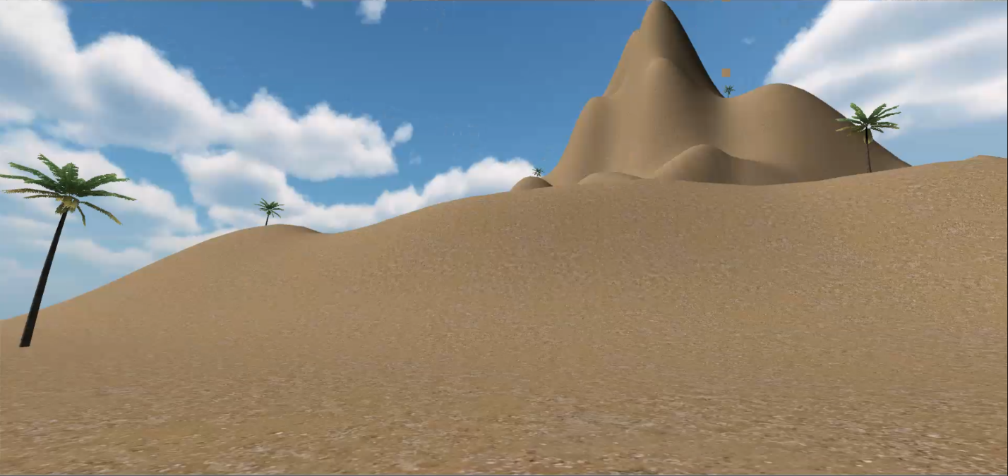

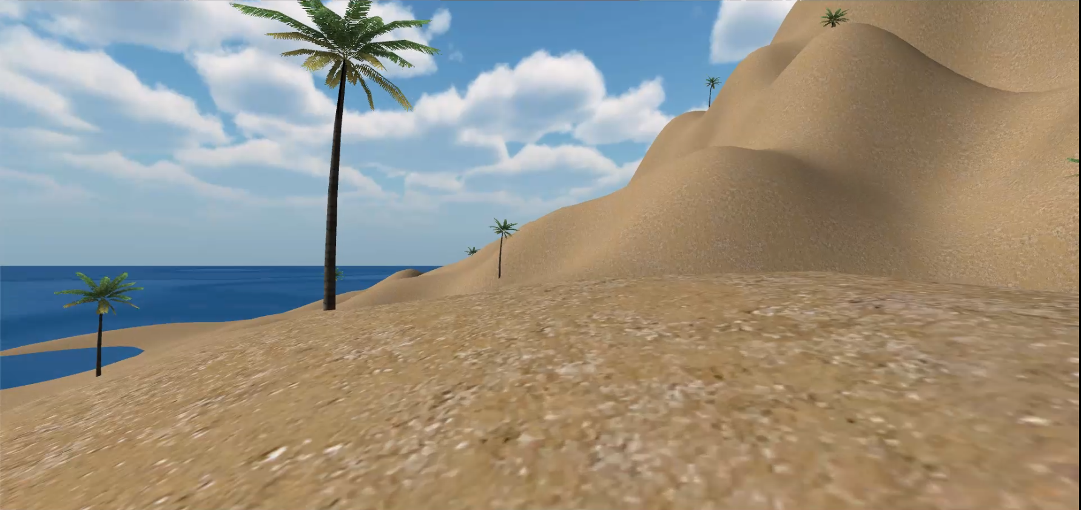

**Functionality**

When it comes to functionality, the project was going to add aspects like proximity sensors, and audio files but they were not included. The avatars that the ship contains are the crew and prisoners. The light or the sky and sun came from the skybox asset in unity. No timers were set in this project but what was intended was for completion of events to happen for the simulation to continue; this project was not intended to be a free run open world simulation but more of an open world objective based simulation.

**Application Usefulness**

Derived from the anime, the only way someone could experience something like this simulation is through Virtual Reality. If the project were just animated, it would be like any other pirate cartoon or movie. The point is for the user to experience the world of Pirates in a real to world simulation. The best technology to run this simulation on is a Virtual Reality headset because of how the user has to go through so many first-person experiences to complete it. Being right there in the action is the best way to experience VRGGGGGHHHHH Pirates.